2nd International Workshop
in
Noninvasive Electrocardiology

Organized by the Cardiology Clinic of the Emergency County Hospital Timisoara
Under the patronage of the International Society of Holter and Noninvasive Electrocardiology

Timisoara, Romania
4 – 6 June 2008

Diagnosis, Prognostic Significance and Therapy of Arrhythmias in Heart Failure

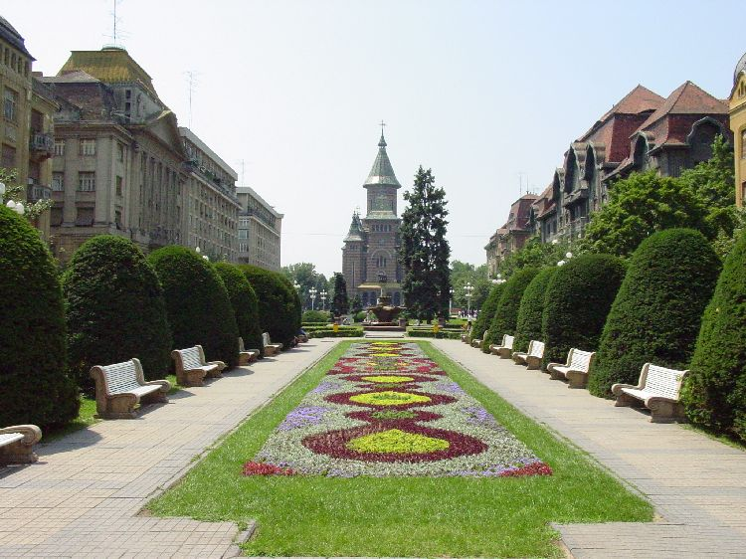

LOCAL ORGANIZING COMMITTEE

President: Prof. Dr. Rodica Avram MD, Ph.D.

Organizer: Victor Dan Moga, MD, PhD
moga.victor@gmail.com
Viviana Ivan, MD, PhD
ivanmvivi@yahoo.com

Secretary: Tudor Ciocârlie, MD
tudorfox@yahoo.com

Members: Livia Brânzan, MD, PhD

Marius Ţurcan, MD, PhD

Doina Rosu MD, PhD

Mariana Tudoran, MD, PhD
Miroslav Nicolin, MD
Mihai Balint, MD
Florina Pârv, MD
Claudiu Popa, MD
Rodica Jurca
Mariana Moga, Eng
Lucian Bosneag, Eng

Congress Master Ltd:
Ioan Cuculescu MD

SCIENTIFIC COMMITTEE
(provisoral)

Honorary President: Wojciech Zareba (USA)
Shlomo Stern (Israel)

President: Rodica Avram (Romania)
Sergio Dubner (Argentina)
Dan Dominic Ionescu (Romania)

Members: Willem J. Remme (Netherlands)
Wilhelm Kaltenbrunner (Austria)
Georg Schmidt (Germany)
Emanuella Locati (Italy)
Ungi Imre (Hungary)
Iwona Cygankiewicz (Poland)
Leonid Makarov (Russia)
Thury Attila (Hungary)
Gerald Maurer (Austria)
Irene Lang (Austria)
Thomas Binder (Austria)
Robert Hatala (Slovakia)
Radu Căpâlneanu (Romania)
Radu Ciudin (Romania)
Gabriel Tatu-Chitoiu (Romania)

MAIN TOPICS:

- Etiology And Epidemiology Of Heart Failure
- Mechanisms of Ventricular Arrhythmias in Heart Failure
- T Wave Alternans for Sudden Death Risk Assessment
- Heart Rate Variability
- Heart Rate Turbulence
- Signal – Averaged ECG
- QT Dispersion and Safety Pharmacology
- The Role Of Autonomic Nervous System In Arrhythmias In Heart Failure
- Atrial Fibrillation: Rhythm vs. Rate Control
- Pharmacological Therapy In Tachyarrhythmias In Heart Failure
- How to Find High-Risk Patients with Heart Failure
- How to Manage Patients with Low Cardiac Function
- Prognostic Of Patients With Heart Failure

LOCATION: Adam Müller-Guttenbrunn House, Timişoara.
There will also be an Exhibition Area for Medical Industry.

OFFICIAL LANGUAGE: English

REGISTRATION: Opened on January 20, 2008

Please send your data - Author(s) name , Affiliation, Contact info and Country - to Congress Master Ltd: office@congress-master.ro

ABSTRACT

Abstract Title - Times New Roman, size 16 font, bold, left aligned, initial capitals.
Authors - Times New Roman, size 12 fonts, Surname, Initials Presenting Author to be bold.
Affiliations - Times New Roman, size 12 fonts, Italics, Affiliation, City, and Country.
Abstract text - Times New Roman, size 12 font, left aligned, maximum 250 words.
Save the abstract as a Microsoft Word document (*.DOC).
The papers will be presented in MS Office, PowerPoint on Windows XP.

Please send abstracts to this email address: moga.victor@gmail.com or tudorfox@yahoo.com, no later then: April 1st, 2008
The date for the confirmation of the accepted papers is:
April 15, 2008.

EARLY FEE April 22, 2008
Symposium:
Romanian participation - 100 RON
International participation - 30 Euro.
Package (Course + Symposium):
Romanian participation - 150 RON
International participation - 45 Euro.
Specialist in training 50 % discount
Accompanying persons 50 % discount
LATE FEE ( after April 22, 2008) or ON SITE
Symposium:
Romanian participation - 180 RON
International participation - 50 Euro.
Package (Course + Symposium):
Romanian participation - 270 RON
International participation - 75 Euro.
Specialist in training 50 % discount
Accompanying persons 50 % discount

The fees should be paid to:
“ Fundaţia Cardioprogress” Timisoara
Fiscal Code: 15396990
Account RON: RO03 BRDE 360S V128 5800 3600
Account EURO: RO63 BRDE 360S V443 5658 3600
BRD Groupe Societe General, Sucursala Timisoara

ACCOMODATION

Continental Hotel****
300054 B-dul Revoluţiei 1989 nr. 5
Tel.: +40-256-494.144 Fax: +40-256-494.145
E-mail: agentie@hotelcontinental.ro, Web site: www.hotelcontinental.ro
Room price: 65-70 Euro

Timişoara Hotel***
300086 Str. Mărăşeşti 1-3
Tel.: +40-256-498.854 • 498.856 Fax: +40-256-499.450
E-mail: receptie@hoteltimisoara.ro, Web site: www.hoteltimisoara.ro
Room price: 42-52 Euro

For other information on accommodation please contact Congress Master Ltd: office@congress-master.ro

"The City of Flowers", "The Paradise of Parks", "The Little Vienna" is only few of the names that made famous the city on the banks of the river Bega. With a population of over 330,000 inhabitants Timisoara, one of the largest and most important cities in Romania, is a multiethnic city, of traditions and culture, defined by the harmoniously living together of Romanians, Hungarians, Germans, Serbians, Croats, Bulgarians and Romanies, each of them keeping their traditions and culture. One of the 4 well-developed university centre of the country, Timisoara also represents an important polarizing centre for Romanian and foreign tourists and business people due to its geopolitical position, the properly trained human resources, the developed material support, and not least the interethnic and inter-religious harmony.
Symbol of Timisoara "Lupoaica" (the wolf), the statue of Romulus and Remus - located in the city centre is the copy of the famous "Lupa Capitolina" in Rome. Also the "House with the Iron Tree" or the "Tree of Guilds", a body of a tree surrounded by an ironed belt that has been driven with ironed nails during several centuries by the skilled workers who crossed Timisoara after they have returned from the "training" journeys made in different cities of Europe.
Other places worth to be visited are: the Victories Square (the Statue of the Wolf, the Metropolitan Cathedral, the Romanian Opera), the Unirii Square (the Catholic Dome, the Baroque Palace, the Fountain with Mineral Water, the Saint Trinity Monument), the Libertatii Square (the Military Casino, the Old Town Hall, the Statue of Decebal Dacian King, the St. Nepomuk Statue), the Maria Square (the Statue of the Virgin), the Huniade Castle - today the Museum of Banat, the Dicasterial Palace, the "Cardinal Points" Fountain, the Decebal Bridge, the Serbian Orthodox Church, the Synagogue.

